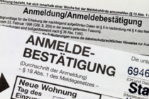[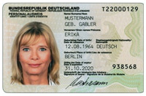](http://www.muenster.de/stadt/pics/neuer-personalausweis500.jpg)

**Anmeldung**

**Sie brauchen für einen Bibliotheksausweis:**

**- den Pass oder Personalausweis**

**- eine Meldebestätigung**

**- Geld**

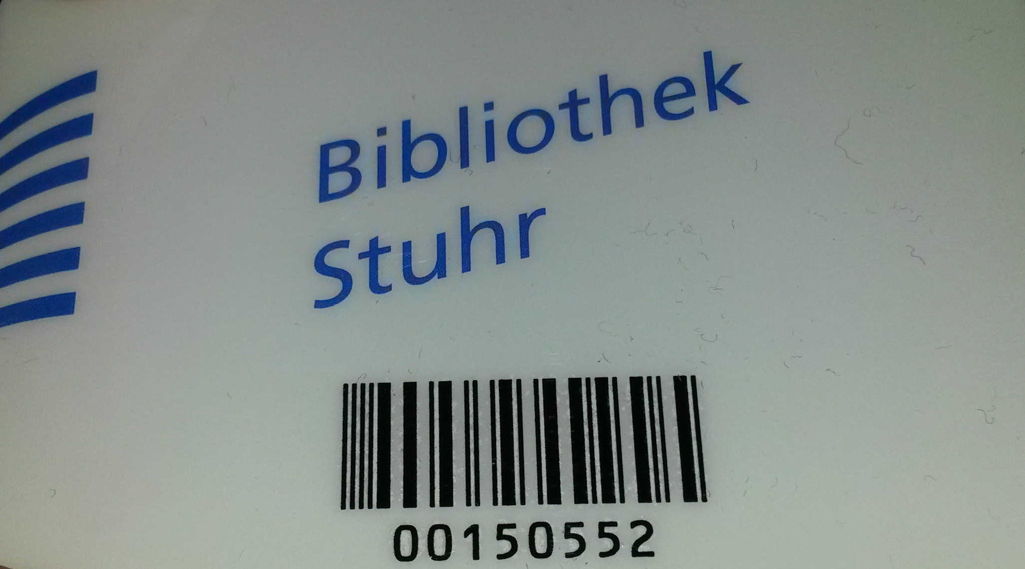

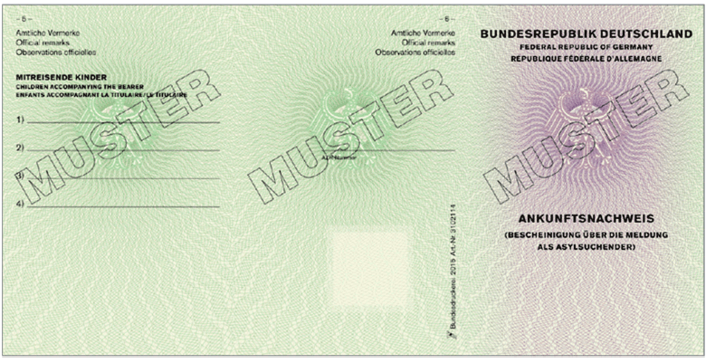

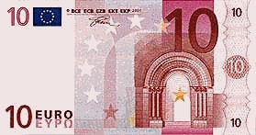

**Bibliothek Stuhr**

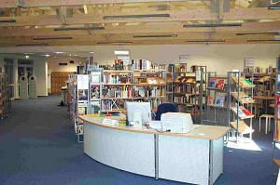[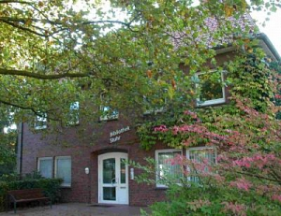](https://www.stuhr.de/medien/bilder/bibliothek_moordeich.jpg?20090122102119)

**Stuhr-Brinkum Stuhr-Moordeich  
Jupiterstr. 1 Neuer Weg 11**

**Dienstag 11 – 19 Uhr Montag 11-17 Uhr  
Freitag 11 – 17 Uhr Donnerstag 11-19 Uhr**

**Medien**

[](http://www.bing.com/images/search?q=B%c3%bccher&view=detailv2&&id=7CCE6236A8C667548814C2DF57B21390DA98A4DD&selectedIndex=1&ccid=6MIq8hx8&simid=608005634495022755&thid=OIP.Me8c22af21c7c4a4a5a64e83c400aec3ao0) [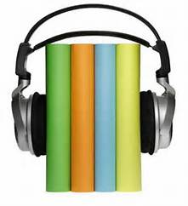](http://www.bing.com/images/search?q=H%c3%b6rbuch&view=detailv2&&id=8ED44D9D54BD167D9730269AF1A85042000E742E&selectedIndex=7&ccid=JYWdJq0d&simid=608029437206071371&thid=OIP.M25859d26ad1d2d0ea47048758de7254ao0) [](http://www.bing.com/images/search?q=H%c3%b6rbuch&view=detailv2&&id=8ED44D9D54BD167D9730269AF1A85042000E742E&selectedIndex=8&ccid=JYWdJq0d&simid=608029437206071371&thid=OIP.M25859d26ad1d2d0ea47048758de7254ao0)

[](http://www.bing.com/images/search?q=DVD&view=detailv2&&id=2ADC18ABDC4185A950B34BA916D7E1C37CCDA7C3&selectedIndex=48&ccid=X6Q7YvMq&simid=607997778990270733&thid=OIP.M5fa43b62f32a434e176dd9ccdeb264c3o0) [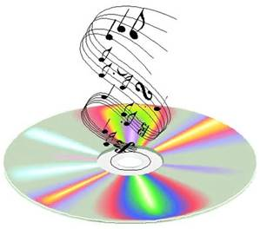](http://www.bing.com/images/search?q=Musik-CD&view=detailv2&&id=21AF69029D166F842633704834EF5BA11FFA537D&selectedIndex=0&ccid=ObUnRjGS&simid=608015160730323281&thid=OIP.M39b52746319291c357d15d43fb048d7fH0) [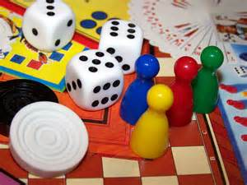](http://www.bing.com/images/search?q=Spiel&view=detailv2&&id=083C3BB329B9CCF40B1F4A0365DB0755FA68B73D&selectedIndex=16&ccid=/QoF0VKX&simid=608026185904033513&thid=OIP.Mfd0a05d152978df62f06aa1f09c4eed3o0)

 [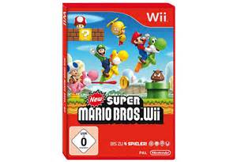](http://www.bing.com/images/search?q=Wii+Nintendo&view=detailv2&&id=5296A50E4D74B0899EBDF1AB51B29FC847DDBABA&selectedIndex=174&ccid=HENXkKIM&simid=608036025680463773&thid=OIP.M1c435790a20c78c55325fcdb911f8cbco0) 

[](http://www.bing.com/images/search?q=Zeitschrift&view=detailv2&&id=3B88E25E2A54EE12EE1ED95678D6E48B8BD0A654&selectedIndex=17&ccid=IQNgypyk&simid=608053248499320217&thid=OIP.M210360ca9ca4997096c5dd9c8b8d7365o0)

[](http://www.bing.com/images/search?q=Zeitschrift&view=detailv2&&id=9FB1B1DDC6963BF82DD3086862CABF6F95879EC9&selectedIndex=903&ccid=vJ4ruFGm&simid=608025838019543659&thid=OIP.Mbc9e2bb851a68dd7ef3667ca16dd07b6o0)

**In der Bibliothek gibt es:**

**- Bücher  
- Zeitschriften, Zeitungen  
- Hörbücher  
- DVD  
- Musik-CD  
- Spiele  
- CD-ROM  
- Computerspiele, Konsolenspiele**



**Leihfristen**

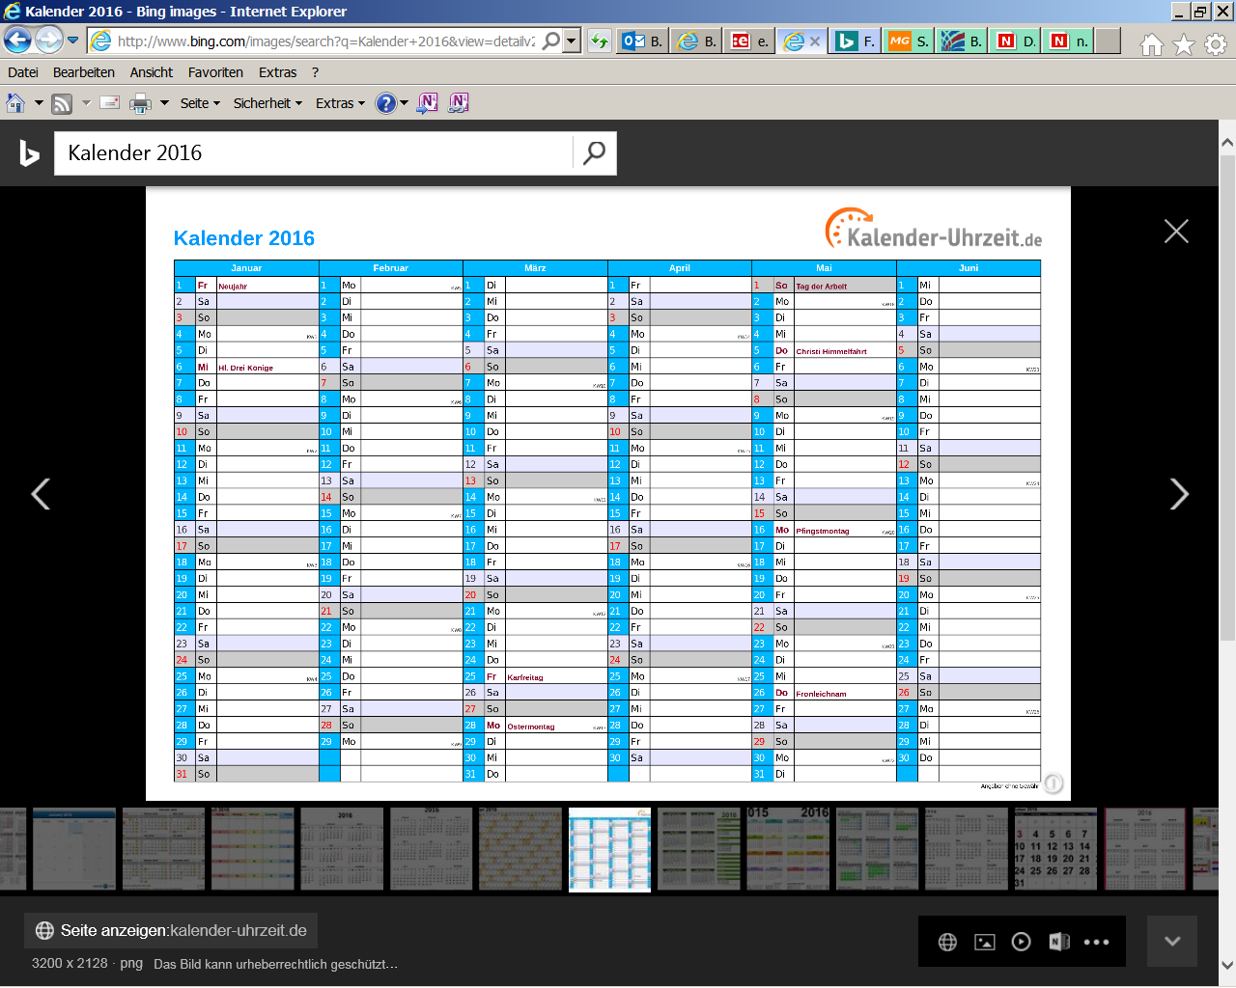 

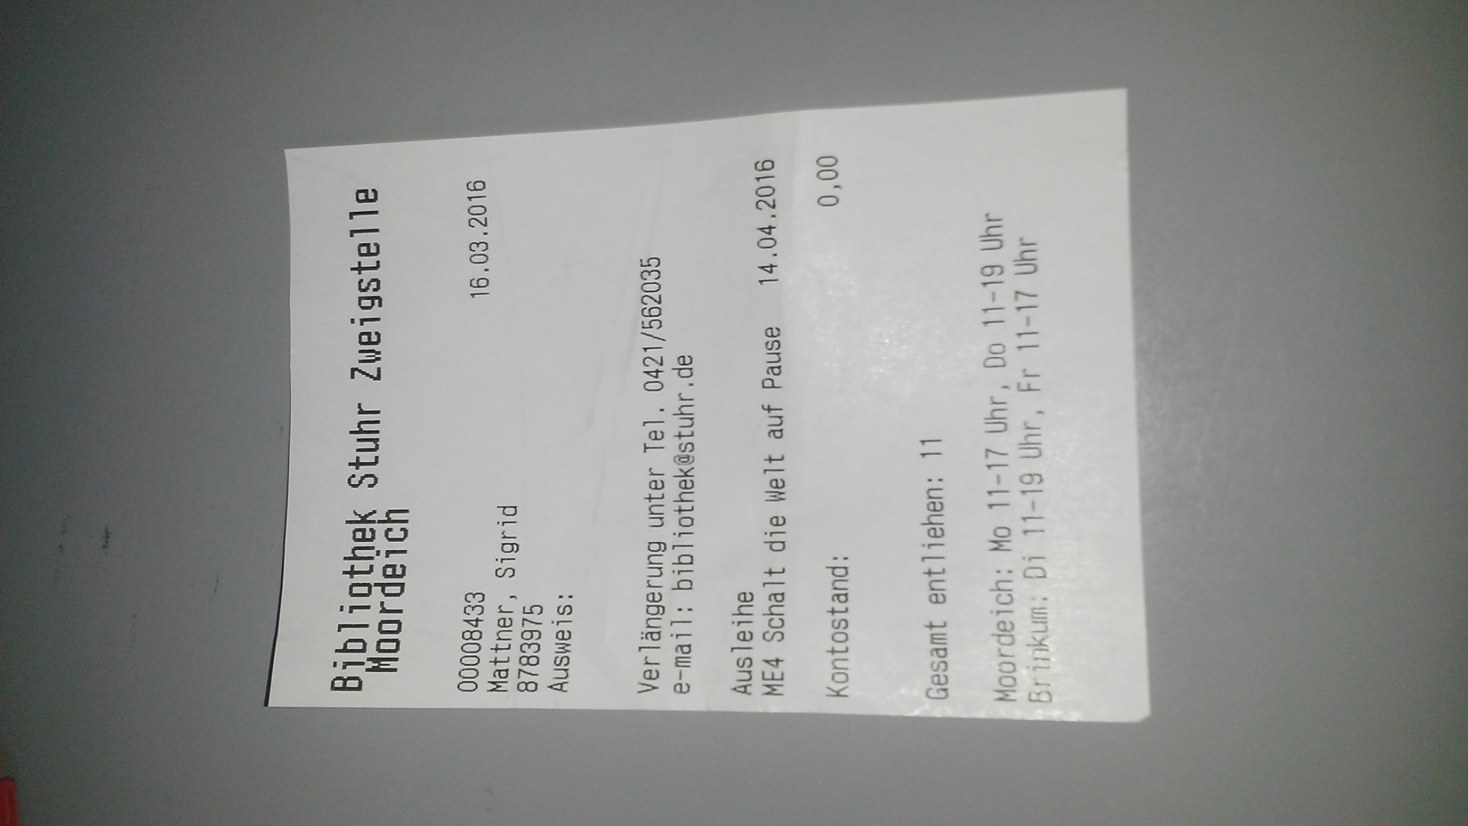

**14 Tage**

[](http://www.bing.com/images/search?q=Zeitschrift&view=detailv2&&id=3B88E25E2A54EE12EE1ED95678D6E48B8BD0A654&selectedIndex=17&ccid=IQNgypyk&simid=608053248499320217&thid=OIP.M210360ca9ca4997096c5dd9c8b8d7365o0)[](http://www.bing.com/images/search?q=DVD&view=detailv2&&id=2ADC18ABDC4185A950B34BA916D7E1C37CCDA7C3&selectedIndex=48&ccid=X6Q7YvMq&simid=607997778990270733&thid=OIP.M5fa43b62f32a434e176dd9ccdeb264c3o0)

[](http://www.bing.com/images/search?q=Musik-CD&view=detailv2&&id=21AF69029D166F842633704834EF5BA11FFA537D&selectedIndex=0&ccid=ObUnRjGS&simid=608015160730323281&thid=OIP.M39b52746319291c357d15d43fb048d7fH0)

[](http://www.bing.com/images/search?q=Wii+Nintendo&view=detailv2&&id=5296A50E4D74B0899EBDF1AB51B29FC847DDBABA&selectedIndex=174&ccid=HENXkKIM&simid=608036025680463773&thid=OIP.M1c435790a20c78c55325fcdb911f8cbco0)

**28 Tage**

[](http://www.bing.com/images/search?q=B%c3%bccher&view=detailv2&&id=7CCE6236A8C667548814C2DF57B21390DA98A4DD&selectedIndex=1&ccid=6MIq8hx8&simid=608005634495022755&thid=OIP.Me8c22af21c7c4a4a5a64e83c400aec3ao0)

[](http://www.bing.com/images/search?q=H%c3%b6rbuch&view=detailv2&&id=8ED44D9D54BD167D9730269AF1A85042000E742E&selectedIndex=8&ccid=JYWdJq0d&simid=608029437206071371&thid=OIP.M25859d26ad1d2d0ea47048758de7254ao0)

[](http://www.bing.com/images/search?q=Spiel&view=detailv2&&id=083C3BB329B9CCF40B1F4A0365DB0755FA68B73D&selectedIndex=16&ccid=/QoF0VKX&simid=608026185904033513&thid=OIP.Mfd0a05d152978df62f06aa1f09c4eed3o0)

**Rückgabe-datum**

00XXXXXX  
Name, Vorname  
Telefonnr.



**Verlängerung der Leihfrist**



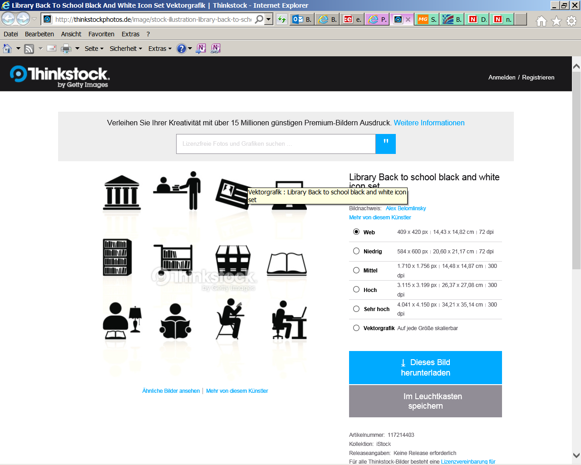[](http://www.bing.com/images/search?q=Email&view=detailv2&qft=+filterui%3alicense-L1&id=D8762894BB33A77BA07B0471C676C19B407CDD94&selectedIndex=0&ccid=ZYxoScBf&simid=608021929599239032&thid=OIP.M658c6849c05f8df72f1fe8b0012f99a2o0) [](http://www.bing.com/images/search?q=aUSRUFEZEICHEN&view=detailv2&qft=+filterui%3alicense-L1&id=8E3FAF75D29201672BBCFCA02B7A830F1CE8A1A5&selectedIndex=2&ccid=kVahCsse&simid=608035072201918064&thid=OIP.M9156a10acb1e0bbce454d96ed3f36ef9o0)[](http://www.bing.com/images/search?q=Telefonanruf&view=detailv2&&id=BD14B5B1B9303FA5B48341CA7E31E550340B6A61&selectedIndex=45&ccid=Ln3jnRBB&simid=608026920350581698&thid=OIP.M2e7de39d104131c23060aad9cc25c14ao0)****

**2 x**

**Was kostet ein Bibliotheksausweis?**

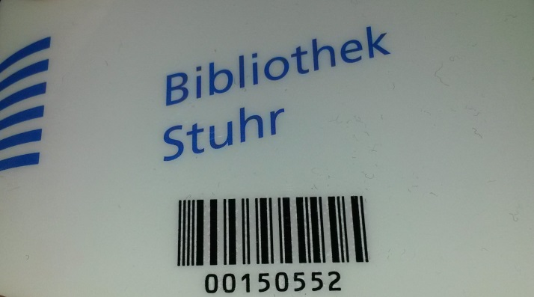

**Erwachsene**

**10 € für 1 Jahr**

**Kinder bis 18 J. 0 €**

[](http://www.bing.com/images/search?q=Erwachsener+Kind&view=detailv2&&id=503511642C9E751E715379D3DE1D37DAA6CD958E&selectedIndex=1&ccid=mBQC2K0e&simid=608036614082661676&thid=OIP.M981402d8ad1e03b276e8a69614dbf5e5o0)

**Schüler und Studenten 18 J. 0 €**

[](http://www.bing.com/images/search?q=Studentenausweis+Bremen&view=detailv2&&id=934F16F5BBC5718F3BF8A0D226CB21E0DBA0F6FD&selectedIndex=1&ccid=w6XzpCwn&simid=608051251339135317&thid=OIP.Mc3a5f3a42c275587ec03e7c28be07675o0)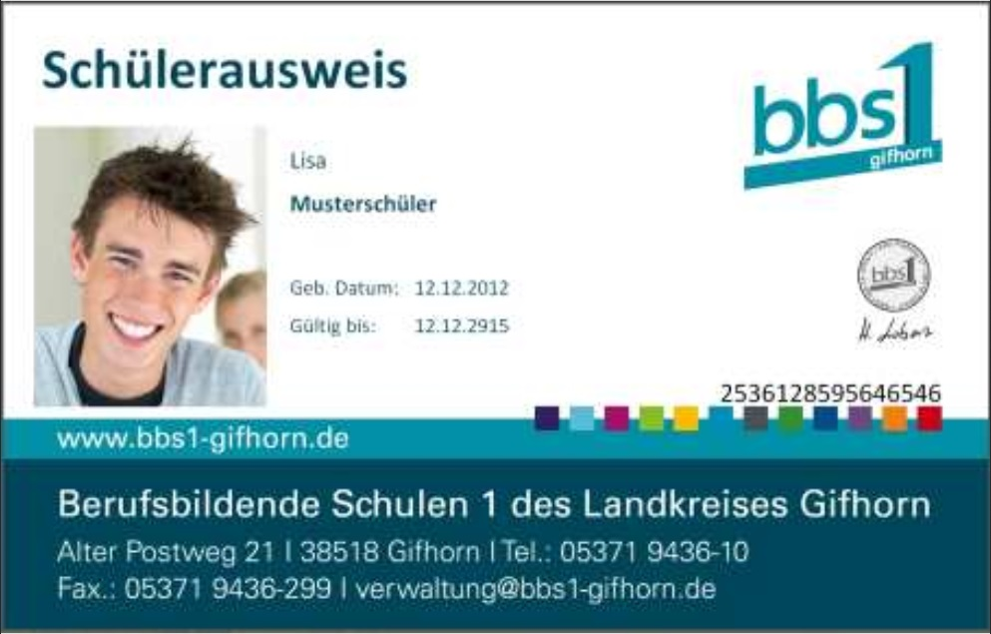

**Was kann man in der Bibliothek machen?**

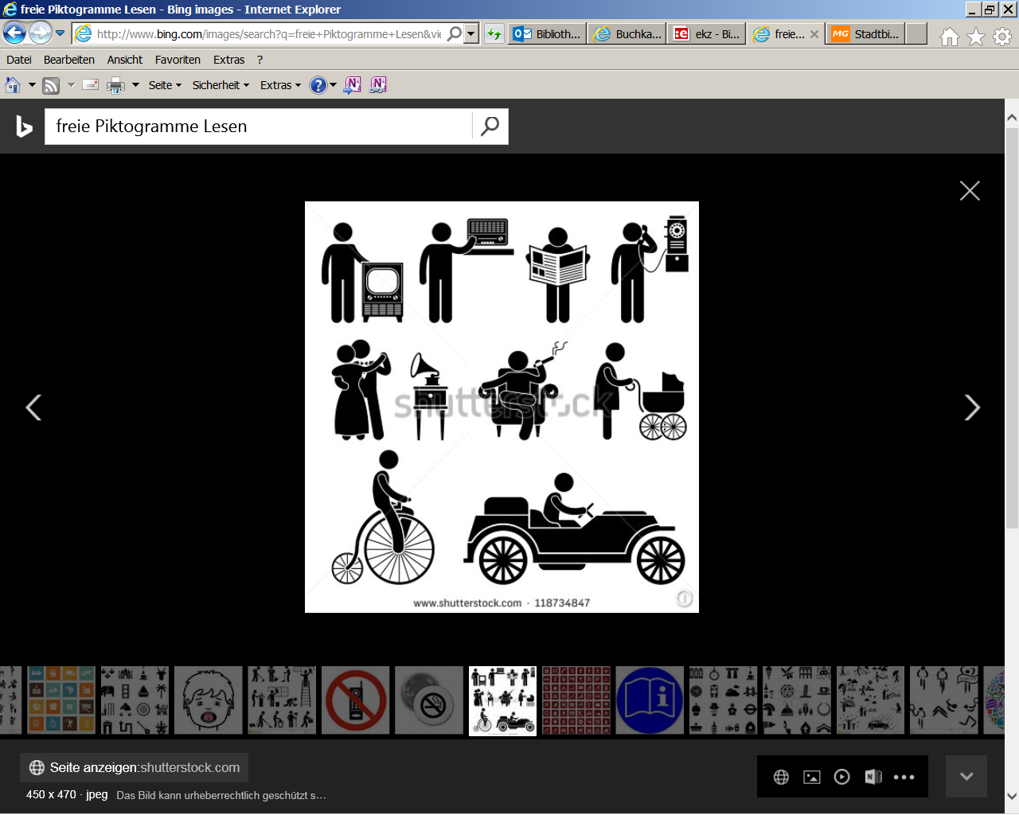 [](http://www.bing.com/images/search?q=freie+Piktogramme+Lesen&view=detailv2&&id=1517E584E7E5129C46F8FC89F1A4A02AA0AF049E&selectedIndex=0&ccid=R604LNhd&simid=608030317671088293&thid=OIP.M47ad382cd85d3b69e3692572199604a1H0) 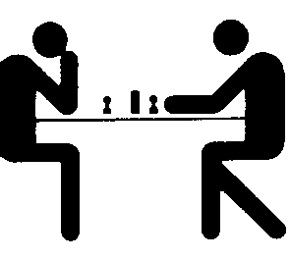 

[](http://www.bing.com/images/search?q=Baby+wickeln&view=detailv2&&id=7C97DA7FDD21DCB7C7E1BF43E2A12B0D271F3B83&selectedIndex=556&ccid=gR42Jgv5&simid=608043228342060437&thid=OIP.M811e36260bf97562450cbfbb5152dcd8o0) 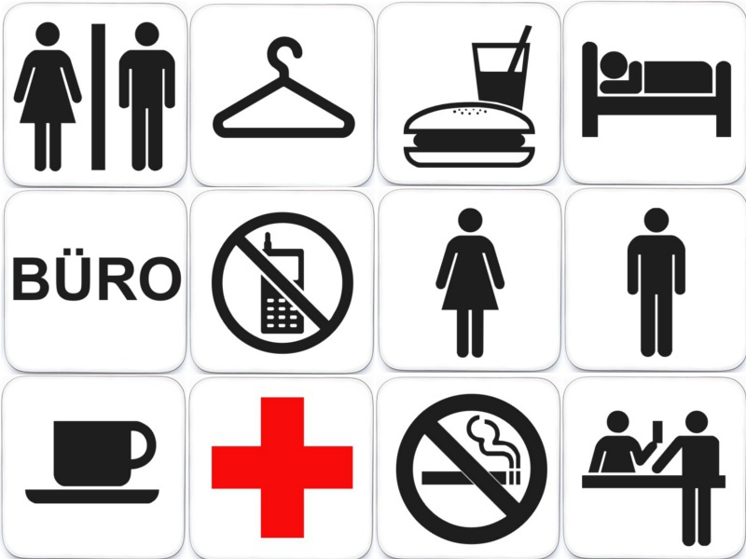**nur im Lesecafé, 0,50 €**

**Was darf man nicht in der Bibliothek?**

 [](http://www.bing.com/images/search?q=rauchen+verboten&view=detailv2&&id=DCF36BC23978B675F621782B2FF282D9EE0D0775&selectedIndex=8&ccid=aXx1TiVq&simid=608038937674124508&thid=OIP.M697c754e256a427cb2b9575d88876ce9o0)  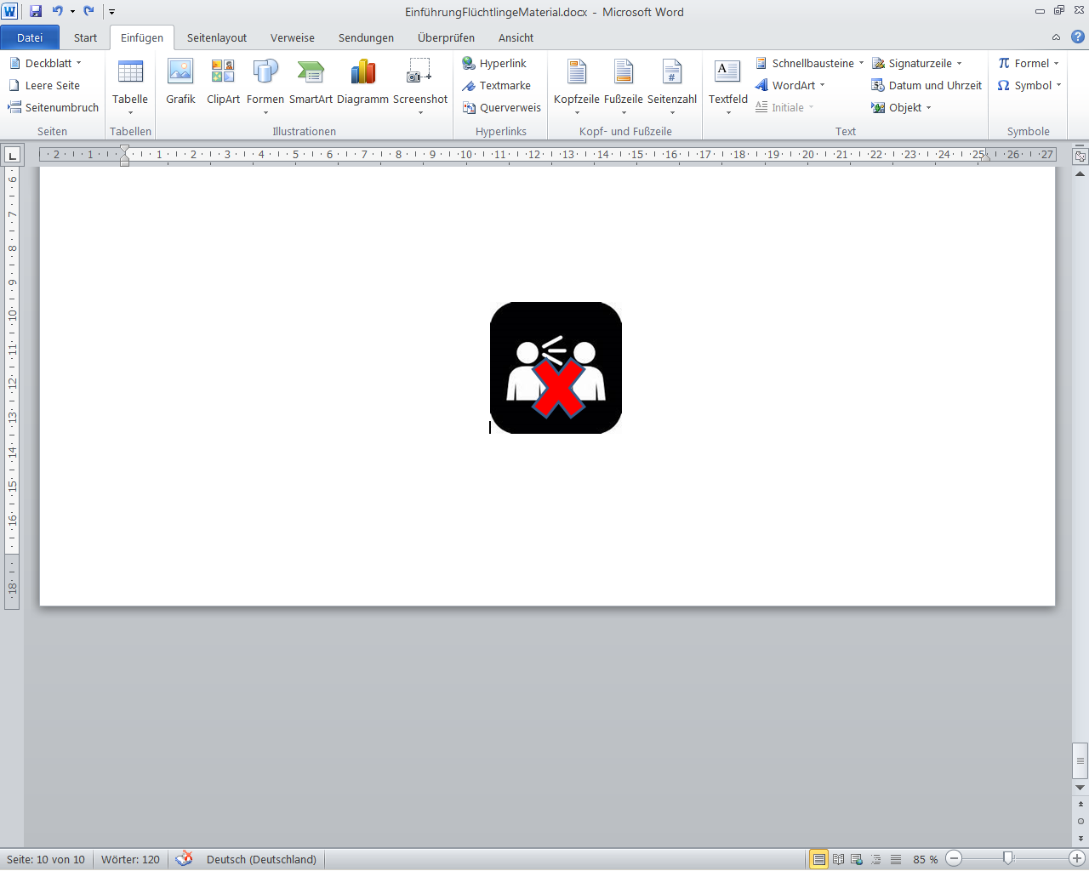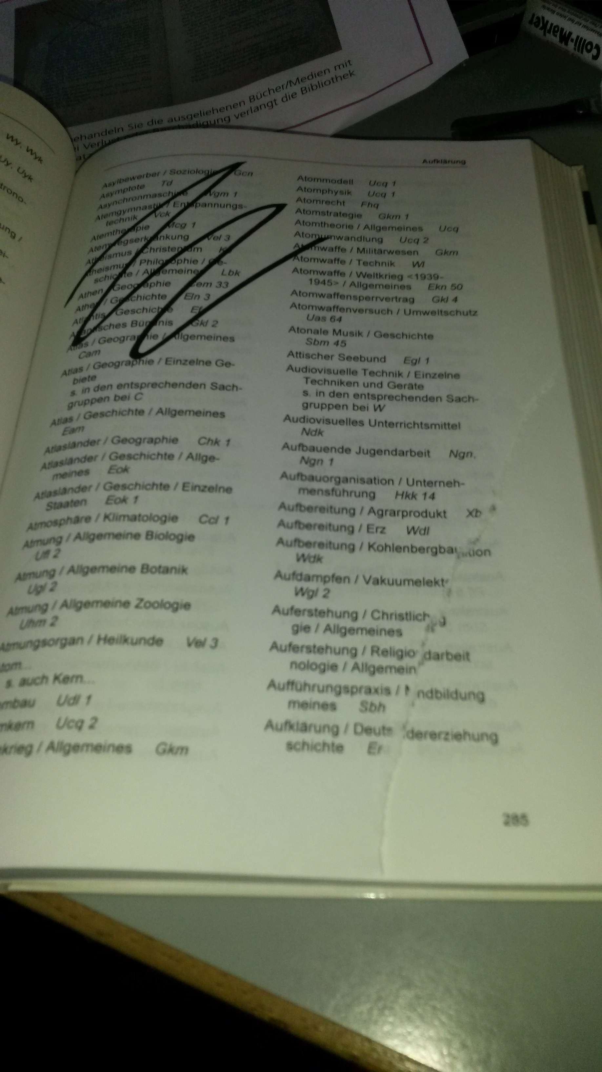 [](http://www.bing.com/images/search?q=Stop&view=detailv2&&id=B65CA40F9EBAD7BD1627EDFBC1AEDD68F060C359&selectedIndex=71&ccid=zAwa603u&simid=608007133435200947&thid=OIP.Mcc0c1aeb4dee62b6f4dcaf4e2af13695o0)

**Gibt es eine Toilette? Ja!**

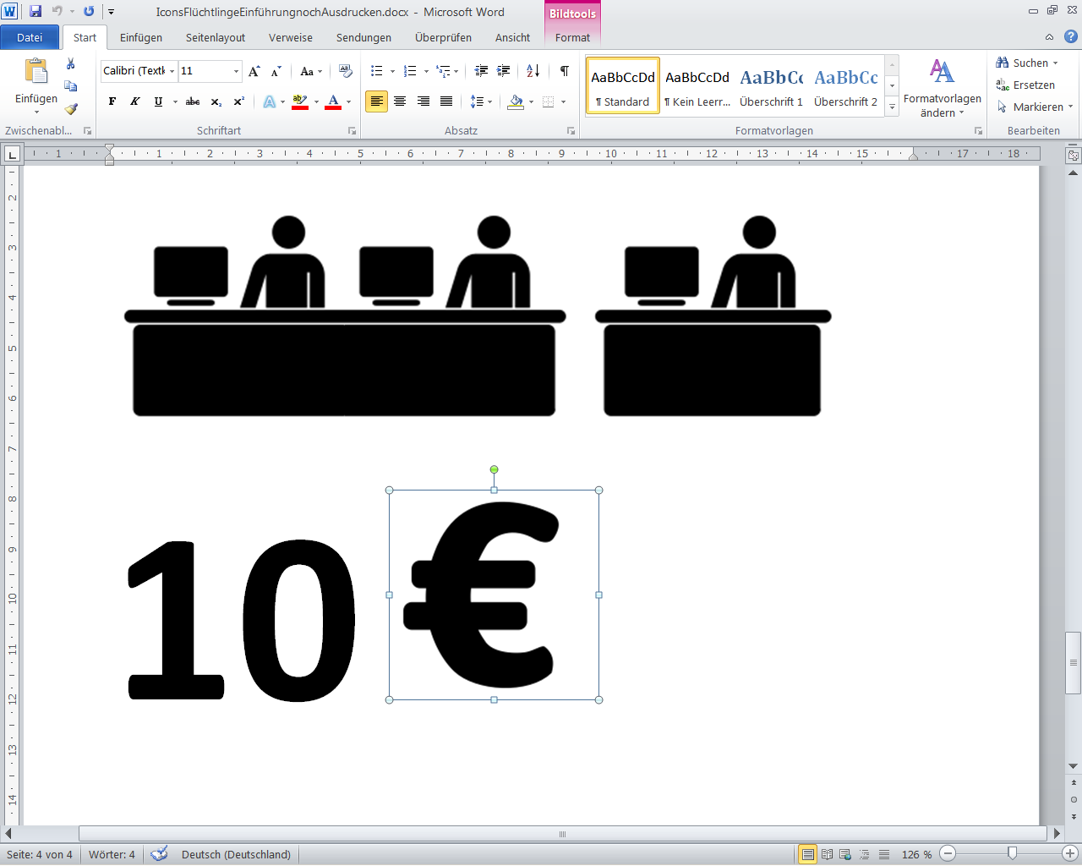

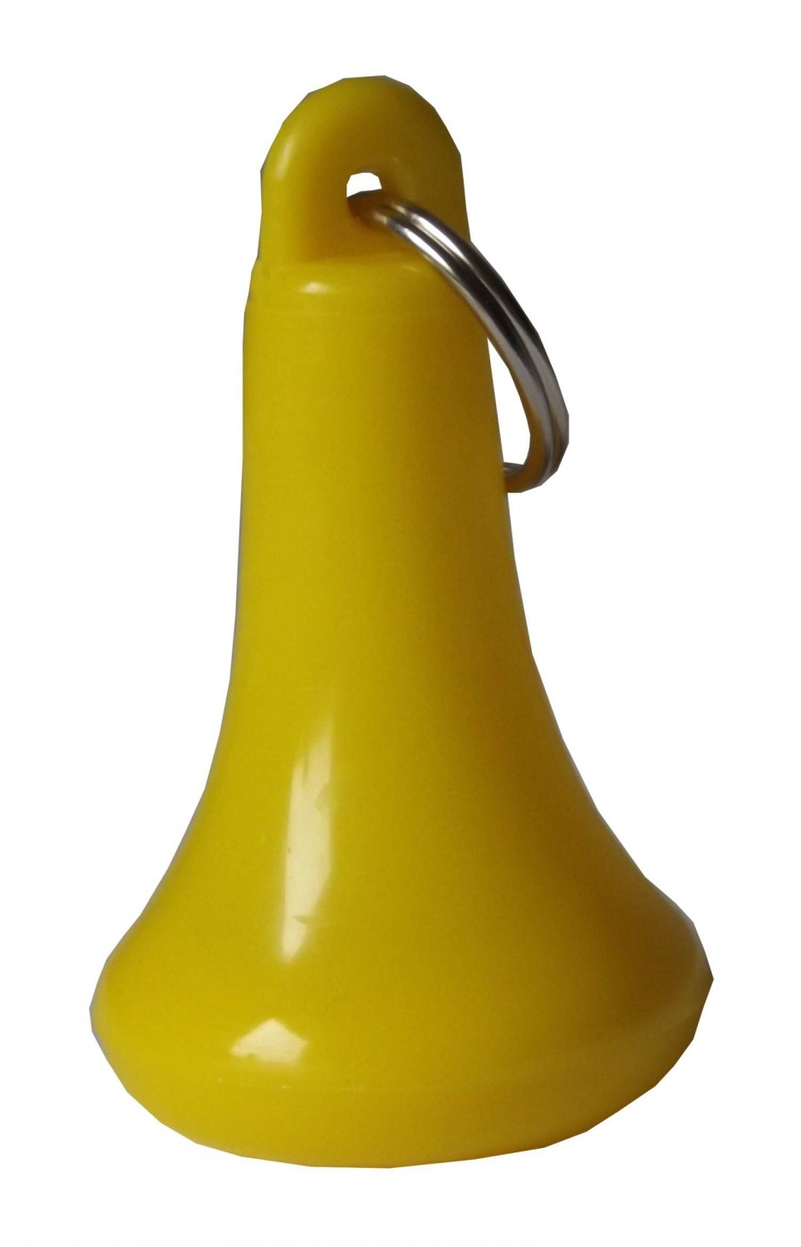

[](http://www.bing.com/images/search?q=Toilette&view=detailv2&&id=33DB96D763F1D9758B3F829F47FF678D332CEEB6&selectedIndex=3&ccid=6ln2oBsu&simid=608043163923976184&thid=OIP.Mea59f6a01b2e296f3e22b55ef7c67fffH0)

Bitte geben Sie mir den Toilettenschlüssel!

[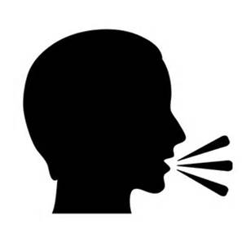](http://www.bing.com/images/search?q=Sprechen&view=detailv2&&id=26F49109BC4D9C87D6429A5E20C8815A067D9FBC&selectedIndex=18&ccid=Pk4gndln&simid=608018235927562467&thid=OIP.M3e4e209dd967e8051db6651b41a0df2fo0)